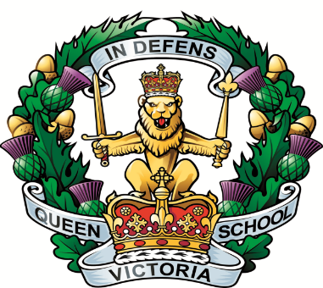

Privacy Notice
What information is being collected?
Queen Victoria School (QVS), as part of the Ministry of Defence (MOD) needs to ask for, and retain personal information regarding potential, present and previous pupils and parents/guardians. This information will include (but is not restricted to) contact details, bank details, medical information, domestic situation, additional support needs and care plans, religion and learning information.
Why is this information being collected?
QVS will only collect and store information which is necessary to educate and provide care and support for its pupils. At all times the information will be used with the well-being of the pupil in mind. Without this information, it would be impossible to provide education and care. We collect and use information fairly and lawfully under Principle 1 of the Data Protection Act 1998, Schedules 2 and 3 of the Data Protection Act, and from 25th May 2018, Articles 6 and 12 of the General Data Protection Regulation.
Who is collecting this information?
This information will be collected by QVS and other selected external support organisations, depending on the circumstances of each situation. It may be necessary for QVS to share information with external support organisations in situations where professional medical or support assistance is needed for the pupil. Please ask if you would like to know in your own situation, who QVS is sharing information with.

How will the information be collected?
The information will be collected from the pupil, parents/guardians, and from named support organisations if necessary, to support the well-being of the pupil. It may be collected in person, on a form, electronically, by post, or by phone/fax.
How will the information be used?
Information will be used to help educate and provide duty of care towards QVS pupils. Where there is a well-being issue, QVS will share information with named external support organisations in support of the pupil. Your consent, and/or the consent of the pupil will normally be asked for. The types of organisation that QVS may share information with are – Education Scotland, Scottish Qualifications Authority, Young Scot, Child and Adult Mental Health Service (CAMHS), Police Scotland, Care Inspectorate, Dunblane Medical Practice, Stirling Social Services, Barnardo’s, Open Secret and Action in Mind. There may be other organisations involved, depending on the situation.
How long will information be kept for?
Any case work regarding pupils will be stored securely at QVS until the child’s 25th birthday. Any non-case work information will be stored for 7 years. Information would normally be destroyed after this time, however due to orders received from the UK government and their devolved administrations, most information is to be stored securely until further notice. QVS will make every attempt to keep the information it holds up to date, and if you are aware of changes to your information, you should inform QVS promptly.
How can I access my information?
In most cases you have a right to access the information QVS holds on you and your child. Your request should ask for the specific information required. Please write to – Library and Information Manager, Queen Victoria School, Dunblane, Perthshire FK15 0JY. The correct process will then be followed, in accordance with Army regulations, and data protection law. If you are submitting a Freedom of Information request, the same instructions apply.

