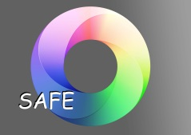 GIRFEC/SAFE Process
Wellbeing Cause for Concern Form – Part 1
To be completed by the person who has the concern.
- Please ensure this completed document is passed onto the HoM.
- The purpose of this form is to pass on wellbeing information about a child/young person through the routine support systems in our school.
- This form should be completed electronically or on paper

- Child/ Young Person’s Details
Name: | DOB: | Year Group:
House: | HoM:

2. Person recording the concern
Name: | Role/designation:
Areas of Concern. Please tick any relevant areas of the Wellbeing Wheel

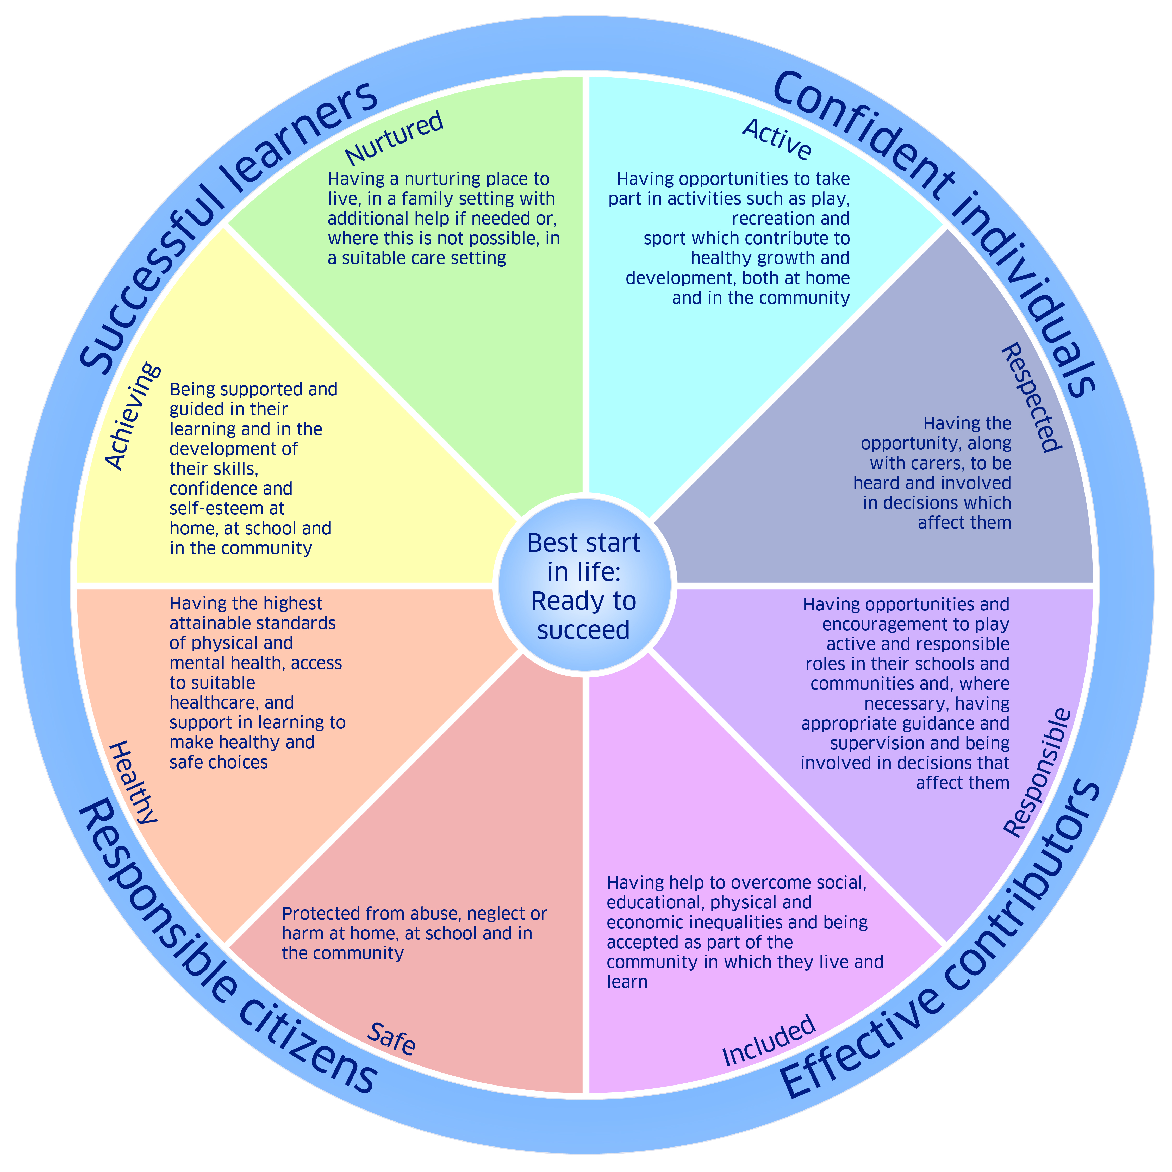

Nature of Concern:
Use the headings you have ticked on the Wellbeing Wheel to record the details below:

PT Informed, please tick in the box if done so.

Previous Action Taken:

Signature: Date:

GIRFEC/SAFE Process
Wellbeing Cause for Concern Form - Part 2
To be completed by the Named Person (HoM)
Please note: This document must be completed by the HoM. Parts 1 and 2 must be distributed to relevant staff prior to the GIRFEC meeting.
Name of CYP: | Completed by (PRINT): | Year Group:
New / Ongoing (please circle)
House: | HoM | Tutor:

    - Have there been previous wellbeing concerns? Yes/No ( please circle)

If yes please summarise with dates.

    - Has this concern been shared with the child/young person? Yes/No ( please circle)

If yes what is the child/young person saying about the concern

    - Has this concern been shared with the child/young person’s parents/carers? Yes/No
( please circle)

If yes please summarise

    - Has the concern been shared with anyone else? Yes/No ( please circle)
If yes please summarise with dates.

    - What action is being taken in relation to this concern?

Continue to monitor

Bring the Child’s/Young Person’s Needs to a GIRFEC planning meeting

Initiate Child Protection procedures
Other – please give any details:

    - Feedback to the referrer.
      - Name:
      - Role/designation:
      - Date:
Name of Named Person ( HoM) …………………………………………Signed……………………………………..
Date………………………….

