Queen Victoria School

Getting It Right For Every Child (GIRFEC)
Policy

“Be SAFE”

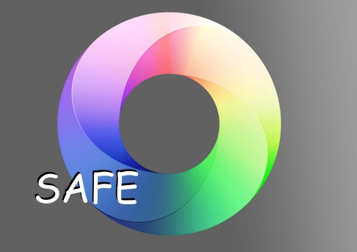

Rev March 2018

Contents

Page

- Glossary

- Introduction

8 Legal Framework

- Link to HGIOS

- What is a wellbeing concern and what does it mean for Queen Victoria School?

13 Stages of Intervention and protocols

19 Child Protection

30 Appendices

54 Acknowledgements

Glossary

Child/Young Person – CYP

- Named Person – HoM

- Lead Professional - DHT(PS) or DHT(P&G)

- Chronology

- Additional Stage Plan

- Formal Stage Plan

- Extended Stage Plan

- Information Gathering Form (IGF)

- Overview Sheet

- Individual Monitoring Profile (IMP) 11.GIRFEC Register
- Well Being Wheel 13.My World Triangle 14.Resilience Matrix

Introduction
The Getting it Right for Every Child (GIRFEC) policy has been developed to provide a rationale and structure within which services to children are planned, developed and implemented. The Getting it Right for Every Child policy should be read in conjunction with the school’s Child Protection Guidelines; as the aim of both is to support Young People.

What is GIRFEC?

GIRFEC places children’s and young people’s needs first, ensures that they are listened to and understand decisions which affect them and that they get more co-ordinated help where this is required for their wellbeing, health and development. GIRFEC also means:

- Getting it right for every child is a way of working which focuses on improving outcomes for all children by placing the child at the centre of thinking, planning and action
- It affects all services that impact on children
- It builds from universal services: moving crisis intervention to early intervention
- It streamlines processes and uses IT to support best practice on information sharing

Core components

  - Improving outcomes for children
  - Common approach to gaining consent and sharing information where appropriate
  - Integral role for children
  - Co-ordinated and unified approach , based on the Wellbeing Indicators
  - Streamlined planning, assessment and decision making - the right help at the right time
  - Co-operation, joint working and communication
  - A Named Person in Universal services is in place for each child and a Lead Professional to co-ordinate and monitor multi-agency planning where necessary
  - Maximising the skilled workforce within universal services
  - A confident and competent workforce across all services
  - The capacity to share demographic, assessment and planning information electronically within and across agency boundaries.

So what does this mean for children? Children will:
- Feel confident about the help they are getting
- Understand what is happening and why
- Have been listened to carefully
- Be appropriately involved
- Be able to rely on appropriate help and have a streamlined and co-ordinated response.

The philosophy behind GIRFEC supports the principles and values of QVS.

Promoting the Wellbeing of individual children and young people

This is based on understanding how children and young people develop in their families and communities and addressing their needs at the earliest possible time.

Keeping children and young people safe

Emotional and physical safety is fundamental and is wider than child protection.

Putting the child at the centre

Children and young people should have their views listened to and they should be involved in decisions that affect them.

Taking a whole child approach

Recognising that what is going on in one part of a child or young person's life can affect many other areas of his or her life.

Building on strengths and promoting resilience

Using a child or young person's existing networks and support where possible.

Promoting opportunities and valuing diversity

Children and young people should feel valued in all circumstances, and practitioners should create opportunities to celebrate diversity.

Providing additional help that is appropriate, proportionate and timely

Providing help as early as possible and considering short- and long-term needs.

Supporting informed choice

Supporting children, young people and families in understanding what help is possible and what their choices may be.

Working in partnership with families

Supporting, wherever possible, those who know the child or young person well, know what they need, what works well for them and what may not be helpful.

Respecting confidentiality and sharing information

Seeking agreement to share information that is relevant and proportionate while safeguarding children and young people's right to confidentiality.

Promoting the same values across all working relationships

Recognising respect, patience, honesty, reliability, resilience and integrity are qualities valued by children, young people, their families and colleagues.

Coordinating help

Recognising that children, young people and their families need practitioners to work together, when appropriate, to provide the best possible help.

Building a competent workforce to promote children and young people's Wellbeing

Committed to continuing individual learning and development and improvement of inter-professional practice.

The Scottish Government: vision for children - supported by eight wellbeing indicators

Children’s wellbeing:

- confident individuals
- effective contributors
- successful learners
- responsible citizens

The 8 wellbeing indicators are:

- Safe
- Healthy
- Achieving
- Nurtured
- Active
- Respected
- Responsible
- Included

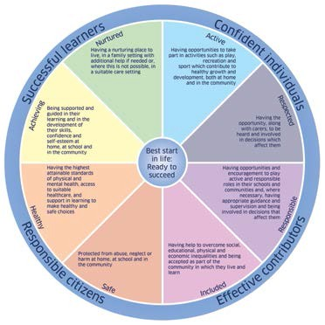

The National Practice Model is a dynamic and evolving process of assessment, analysis, action and review, and a way to identify outcomes and solutions for individual children or young people. It allows practitioners to meet the Getting it right for every child core values and principles in
an appropriate, proportionate and timely way.
It contains the key elements of a single planning process that should in turn lead to a single child’s plan - if one is needed.

It is a way for all agencies and workers who support children, young people and their families to begin to develop a common language within a single framework, enabling more effective inter- and intra-agency working.

Using the National Practice Model in this consistent way allows practitioners in any agency or organisation to construct a plan and take appropriate action. It also allows for regular and consistent reviewing of the plan.

For more information visit www.scotland.gov.uk/gettingitright/

Legal Framework

GIRFEC is a key policy driver to improve outcomes for all children and young people. It is a national approach that overarches all other policies for children and young people and families. It provides the strategic policy framework supporting other key policies and initiatives.

United Nations Convention on the Rights of the Child (UNCRC)

GIRFEC has its roots in the United Nations Convention on the Rights of the Child (UNCRC). The focus is to provide stronger focus on early intervention and support, be more effectively integrated, more efficient and better focused on the child. The Act puts key elements of GIRFEC into Statute.

(Getting it Right for Children and families, The Scottish Government)

For further information visit www.unicef.org/crc/

Children (Scotland) Act 1995

The principles contained within the Children (Scotland) Act 1995 underpin the Getting it Right for Every Child policy.

These are:

- every child has the right to be treated as an individual;
- every child has the right to have her/his views heard, recorded and where safe to do so acted upon;
- parents should normally be responsible for the upbringing of their children;
- every child should be protected from all forms of abuse, neglect or harm;
- the child’s welfare must be the paramount consideration when decisions are being made about the child;
- the child should, where it is consistent with their welfare, be cared for by their family; and
- authorities should only seek an order in respect of a child where it is in the child’s best interest.

For further information visit http://www.legislation.gov.uk/ukpga/1995/36/contents

The Education (Additional Support for Learning) (Scotland) Act 2009

  - establishing the concept of additional support needs
  - placing new duties on local authorities and other agencies
  - setting out rights for parents

- establishing mechanisms for resolving differences for families and authorities, mediation, dispute resolution
- establishing the Additional Support Needs Tribunals Scotland.

Children and Young People Act 2014

The Act and accompanying documents have been published on the Scottish Parliament website. Read more about the Children and Young People (Scotland) Act

The Act will further the Scottish Government’s ambition for Scotland to be the best place to grow up in by putting children and young people at the heart of planning and services and ensuring their rights are respected across the public sector.

For further information visit

http://www.legislation.gov.uk/asp/2014/8/enacted

http://www.scottish.parliament.uk/parliamentarybusiness/Bills/62233.aspx

(Getting it Right for Children and families, The Scottish Government)

Link to HGIOS

CORE PRINCIPLES

Effective systems allowing relevant and timely sharing of information between parents, teachers, children and armed forces personnel are fundamental to the QUEEN VICTORIA SCHOOL S.A.F.E process.
It is vital that close contact is maintained with military families to ensure that shared decisions are made, which have the welfare of the CYP at the heart of the process.
The GIRFEC initiative links closely to the approach taken in HGIOS 4 and has at its centre the Key Question, How good can we be?
Three main themes are exemplified in HGIOS 4, with the theme of Learning Provision How good is the quality of care and education we offer at the centre of GIRFEC.

2.1 Safeguarding & Child Protection

Ensuring that CYP are safe, well cared for and enabled to flourish.
CYP are resilient and develop a sound understanding of how they can keep themselves safe.

Personalised Support

The focus is on the provision of high quality support, enabling all CYP to achieve success. A Child’s Plan will be used to manage the wellbeing needs of any child or young person who requires a targeted intervention – which is support not generally provided to all children through universal services.

Family Learning

Emphasising the positive impact of working with families to improve learning and achievement.

Transitions

This indicator focuses on the need for CYP to be well supported as they move into school, through school and beyond school.

Within the theme Successes and Achievements How good are we at ensuring the best possible outcomes for all our learners, the QI Ensuring wellbeing, equality and inclusion is fundamental to GIRFEC.

  - Ensuring wellbeing, equality and inclusion is fundamental to GIRFEC

This indicator focuses on the impact of the school’s approach to wellbeing, which underpins CYP’s ability to achieve success.

What is a Wellbeing Concern?

A child or young person has a wellbeing need if their wellbeing is, or is at risk of, being adversely affected by any matter. A wellbeing concern may be identified by the child, or young person, or by anyone who knows or supports the child or young person, and can be identified for many reasons, such as (but not limited to) the following:

    - a child or young person may be worried, anxious or upset about an event/set of circumstances, including socio-economic circumstances;
    - a parent/carer or family member may have noticed a change in the child or young person’s behaviour, demeanour or developmental progress;
    - a parent/carer may have concerns about the impact on their child of an event or set of circumstances;
    - a practitioner may have concerns for a child or young person’s health, or may have noticed a change in their behaviour, demeanour, developmental progress or level of achievement;
    - a child or young person may be offending, or putting themselves at risk of harm.

A wellbeing concern will arise from observation or assessment which indicates that one or more aspects of wellbeing is, or is at risk of being, adversely affected or subject to an effect by factors related to the child, or young person. Professional judgement based on experience and training and information about the child, or young person, and their circumstances, will be key to identifying wellbeing concerns. In some cases a single observation or incident may be judged to represent a risk to wellbeing and be considered a concern. In other cases the context of the observation or assessment, and wider knowledge of the child’s general wellbeing and circumstances may either heighten or reduce the concern. The nature of the concern will be specific to the individual child, their age, stage of development and circumstances, so what represents a wellbeing concern for one child, may not be judged a concern for another child.

What does it mean to QVS?

The majority of pupils at QVS will not need a Child’s Plan as their wellbeing needs will be met by their parents or carers and through routine activity and planning within health and education services.

There are two main considerations in deciding if a child requires a Child’s Plan. The first is based on an assessment of their wellbeing. The child must be assessed as have a wellbeing need in terms of the definition of wellbeing with the Child and Young People (Scotland) Act 2014. This means that a judgement has been made that the child’s wellbeing is currently being adversely affected by any matter, or at risk of being adversely affected. The adverse effect may be one or more aspects of wellbeing and can arise from any factors relevant to the child. The second consideration relates to the support judged necessary to meet the identified need.

Our ‘S.A.F.E’ process has been developed to provide a simple, effective process, creating a structured early intervention strategy for young people at the school. The school’s aim is to deliver an assessment framework based on the two considerations mentioned above, the needs of the children, the support required and to build a Team Around the Child (TAC).

Stages of Intervention

The aim is for early intervention to provide timely and suitable intervention to meet the wellbeing needs of the individual by implementing the National Practice Model which is ‘a dynamic and

evolving process of assessment, analysis, action and review, and a way to identify outcomes and solutions for individual children or young people.’

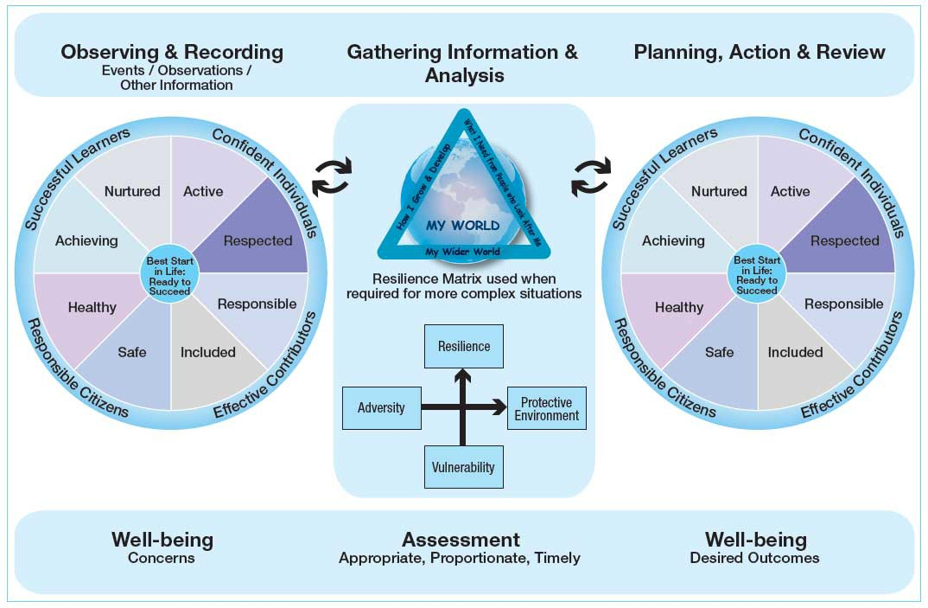

There are FOUR stages of intervention within the S.A.F.E process:

Support Stage Additional Stage Formal Stage Extended Stage

SUPPORT Stage

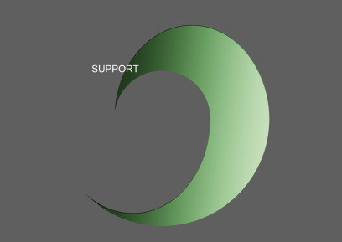

Ongoing House and/ or Department concerns raised.

- Only if CYP concerns are ongoing in the House/ Department should they be raised to Support Stage. Interventions at Support Stage are low level and House/Departmental based.
- All information on CYP should be forwarded to HoM. This will include academic, emotional, behavioural, social and pastoral matters. Teaching staff to liaise with PS Department for advice on low level strategies. Initial concerns recognised and low level intervention to be set and implemented in consultation with the CYP. This support is not formal and is House or class based. Parents may be informed if required.
- Progress of CYP should be monitored. If CYP responds positively, strategies may continue or be

withdrawn.
- If concerns persist or worsen then…initiate Additional Stage
- Standardised Support Programme in House/Department.

Additional Stage

Required Intervention.

- Further Ongoing concerns recognised and further intervention required to meet the wellbeing needs of the child.
- All concerns, including academic, should be raised directly with the HoM. HoM to notify PS Department.
- HoM to initiate gathering of information and analyse the wellbeing needs, from ALL aspects of CYP’s school life, this will include information from WCBS (This may also include PS assessment, EP referral, observations in class and boarding house and medical input).
- HoM to initiate and support the National Practice Model to establish more information about the CYP - by CYP, parents (if possible) and HoM & other staff as required.
- Weekly agenda created at each GIRFEC meeting and sent out by PS Department. All attendees to have information 48 hours prior to review meeting.
- Aim of meeting- to discuss concerns raised, actions already taken and to create an Additional Plan
based on up to date relevant information. Information must be related to wellbeing indicators.
- Review date set.
- HoM continues to monitor and update Chronology.

Outcome: Satisfactory - continue with intervention, option to drop down stage of intervention or if concerns persist or worsen then… Initiate Formal Stage.

Protocol for Additional stage.

- Time window: 7-10 days to complete.
- PS to inform HoM of education concerns.
- HoM to initiate information gathering from staff using IGF, from ALL aspects of CYP’s school life, this will include information from WCBS (may include PS assessment, EP referral).
- HoM to complete National Practice Model with input from CYP and relevant staff.
- HoM responsible for all information collated and provided to staff involved in preparation for the review meeting.
- Pupil Support to create Additional Stage Plan and email all attendees and any other relevant staff.
- Action points agreed and minuted by DHT PS.
- HoM to discuss Plan with CYP who will sign and comment on the Plan and CYP form, as appropriate.

- Plan returned by HoM to DHT(PS) to send to parent.

DHT to chair meeting
- Suggested standing agenda items for Additional Stage meeting:

  - Previous Action Points
  - Review nominated pupils and any pupils whose plans are due for review
  - Statement about cause for concern.
  - Action already taken.
  - Discussion points /update.
  - Action points for Additional Plan.
  - Staff responsibilities.

Required Intervention.
Formal Stage

Option one: Movement from Additional to Formal Stage – No referral form required. Option two: No previous intervention used, Cause for Concern form required.
- HoM to complete Referral form, if required and send to DHT(PS).
- Review meeting to evaluate information collated (The National Practice Model, observations, referral form, Chronology)
- Formal Plan created (this may include IEP, Educational Psychologist support, as required).
- Review date set.
- PS Dept MUST be present at review meetings.
- HoM continues to monitor and update Chronology.
- Outcome: Satisfactory - continue with intervention, option to drop down stage of intervention or if concerns persist or worsen then… initiate Extended Stage.

Protocol for Formal Stage

- If required, HoM to complete Cause for Concern form and send to DHT(PS) and all relevant staff.
- HoM to initiate agenda for meeting
- HoM responsible for providing up to date, relevant information and to present information at the meeting.
- DHT (PS) to chair meeting, Pupil Support to create Formal Plan. Action points agreed and minuted by DHT(PS).
- HoM to discuss Plan with CYP.
- Suggested standing agenda items for Formal Stage meeting:

  - Previous Action Points
  - Review nominated pupils and any pupils whose plans are due for review
  - Statement about cause for concern.
  - Action already taken.
  - Discussion points /update.
  - Action points for Formal Plan.
  - Staff responsibilities.

Extended Stage

- Review meeting to evaluate information (The National Practice Model, observations, referral form, Chronology).
- Multi-Agency intervention will be required for long term intervention.
- CYP and parents involved and will be invited to attend review meeting, if required.
- Review date set.

Protocol for Extended Stage

- HoM responsible for providing up to date, relevant information and to present information at the meeting.
- DHT(PS) to chair meeting, PS to review Plan. External support requirement. Action points agreed and minuted by DHT(PS).
- Suggested standing agenda items for Extended Stage meeting:

  - Previous Action Points
  - Review nominated pupils and any pupils whose plans are due for review
  - Statement about cause for concern.
  - Action already taken.
  - Discussion points /update.
  - Action points for Extended Plan.
  - Staff responsibilities.

Child Protection

The Safeguarding and Child Protection Policy helps to provide an immediate intervention strategy, within GIRFEC, to help safeguard and protect children and young people. When Child
Protection action is deemed necessary, due to the nature of the concern identified, the matter must be reported immediately to the designated Child Protection Coordinator, DHT(P&G). The concern will be progressed and guidelines adhered to as stated in the Safeguarding and Child Protection Policy and will bypass other stages of intervention, if required.

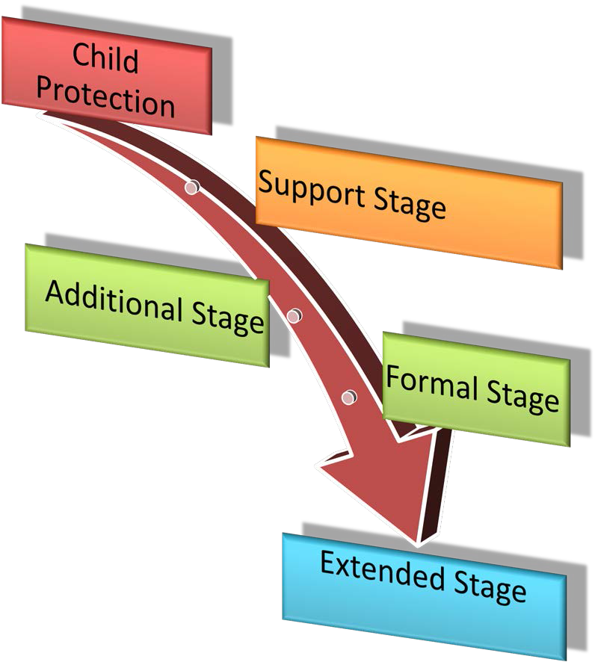

Named Person – HoM

The role of the Named Person

The Getting it right approach includes a Named Person for every child, from birth (or sometimes before) until they reach 18, or beyond if still in school.
In most cases, the Named Person will not have to do anything more than they normally do in the course of their day-to-day work. The major difference will be that they use the National Practice Model as a starting point for recording both routine information about a child or young person and for when they have particular concerns.
Most children and young people get all the help and support they need from their families, from teachers and health practitioners, and from their wider communities. But some may need extra help and that's where the Named Person comes in.
Depending on the age of the child or young person, a health visitor or teacher usually takes the role of Named Person. This means that the child and their family have a point of contact who can work with them to sort out any further help, advice or support if they need it.
Once a concern has been brought to their attention, the Named Person – who will be the first point of contact for the child and their family – needs to take action, help, or arrange for the right help in order to promote the child’s development and wellbeing.

Referring to the eight Wellbeing Indicators, they will need to ask these five questions:

- What is getting in the way of this child or young person’s wellbeing?
- Do I have all the information I need to help this child or young person?
- What can I do now to help this child or young person?
- What can my agency do to help this child or young person?
- What additional help – if any – may be needed from others?

The Named Person also needs to help children and families feel confident they can raise concerns and talk about their worries to people who will listen and respect their point of view and work with them to sort things out. Above all, they will ensure that the child or young person’s views are listened to and that the family (where appropriate) is kept informed.

Lead Professional - DHT(PS) or DHT(P&G). The role of the Lead Professional
When two or more agencies need to work together to help a child or young person and family, there will be a Lead Professional to co-ordinate that help.

The Lead Professional:

  - makes sure that the child or young person and family understand what is happening at each point so that they can be involved in the decisions that affect them
  - acts as the main point of contact for children, young people, practitioners and family members, bringing help to them and minimising the need for them to tell their story several times
  - promotes teamwork between agencies and with the child or young person and family
  - ensures the child’s plan is implemented and reviewed
  - is familiar with the working practices of other agencies

- supports other staff who have specific roles or who are carrying out direct work or specialist assessments
- ensures the child or young person is supported through key transition points, particularly any transfer to a new Lead Professional
- ensures the child’s plan is accurate and up-to-date.

Wellbeing Cause For Concern Forms
- in 2 parts:
Part 1 - completed by member of staff with concern Part 2 - completed by HoM

- Chronology: (initiated by the HoM) will be held on all CYP. Provides an accurate account of all significant events that have occurred in the life of the CYP. (Note: Confidential information will not be held on the Chronology – A note referring to the matter may be made).

- Additional Stage Plan: Low level, short term intervention strategies to support the needs of the CYP.

- Formal Stage Plan: Detailed account of intervention strategies required and key people involved to support the CYP.

- Extended Stage Plan: Multi agency approach, providing a detailed account of intervention strategies required and key people involved to support the CYP.

- Information Gathering Form (IGF): Electronic document used to gather information about a CYP from all aspects of school life.

- Individual Monitoring Profile (IMP): Document to evidence all relevant discussions with CYP as agreed in the CYP’s Plan.

- GIRFEC Register: held and up dated by the CYP Support Department in consultation with other staff. The register will include all stages of intervention.
  - Well Being Survey: The Wellbeing Survey is used to promote discussion between CYP and staff. It focuses on the eight Wellbeing Indicators and can be used to help collate, summarise and share information. The Wellbeing Indicators are also used when a plan is being constructed or reviewed, to summarise the child or young person’s needs.

SHANARRI Assessment
Using “Getting It Right” indicators of Wellbeing to guide discussion about key areas of a CYP’s life.

Safe Healthy Active Nurtured Achieving Respected Responsible Included

Designed to…

  - Be simple to use and understand
  - Be an interactive and engaging process to measure outcomes
  - Focus on both potential and problems
  - Support and assist growth and change
  - Provoke discussion about issues and create a graphic scale which shows the person’s progress and journey of change
  - Be used to inform discussion during review meetings

- The ‘My World Triangle’ To help staff understand a CYP’s whole world. It can be used to explore their experiences, recognising there are connections between the different parts of their world. In assessment it can be used to explore needs and risks.

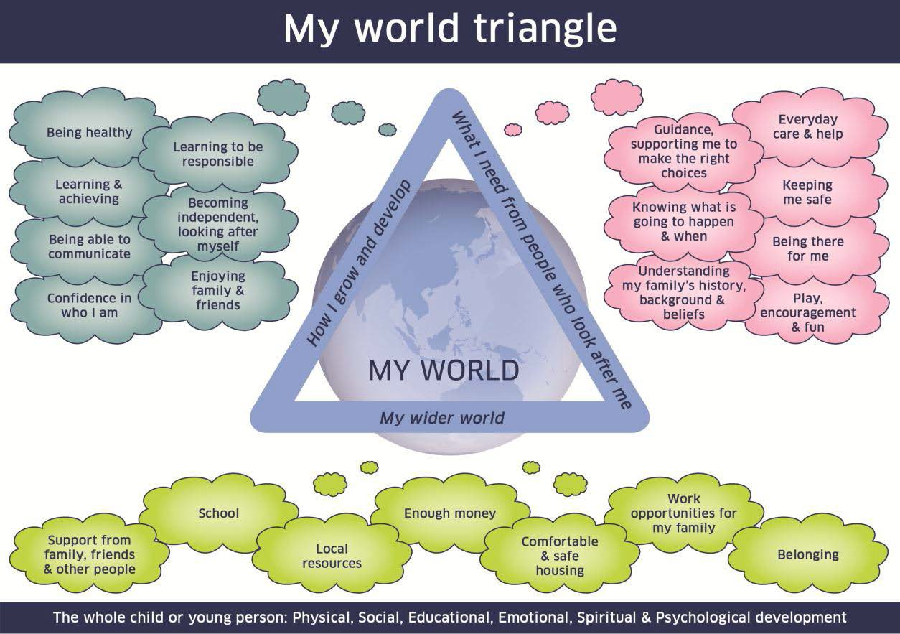
Using the My World Triangle allows staff to consider systematically:

  - how the child or young person is growing and developing
  - what the child or young person needs from the people who look after him or her
  - the impact of the child or young person’s wider world of family, friends and community

How I grow and Develop

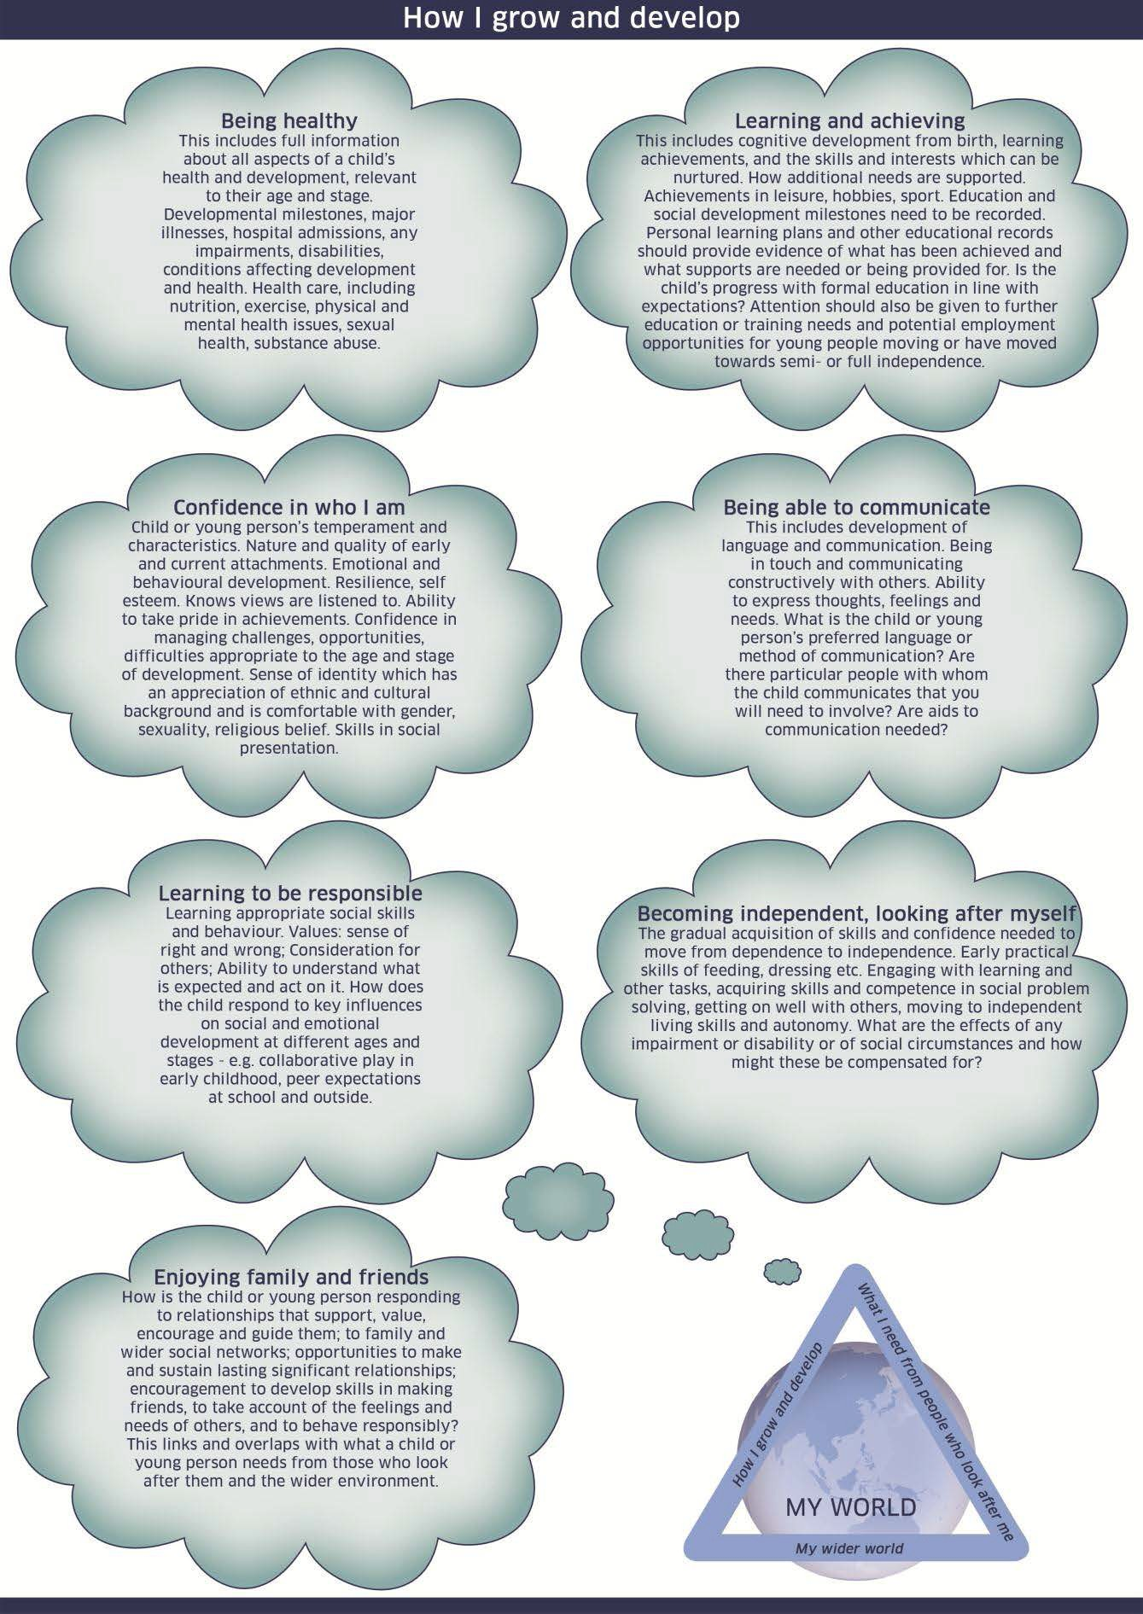

What I need from People who look after me

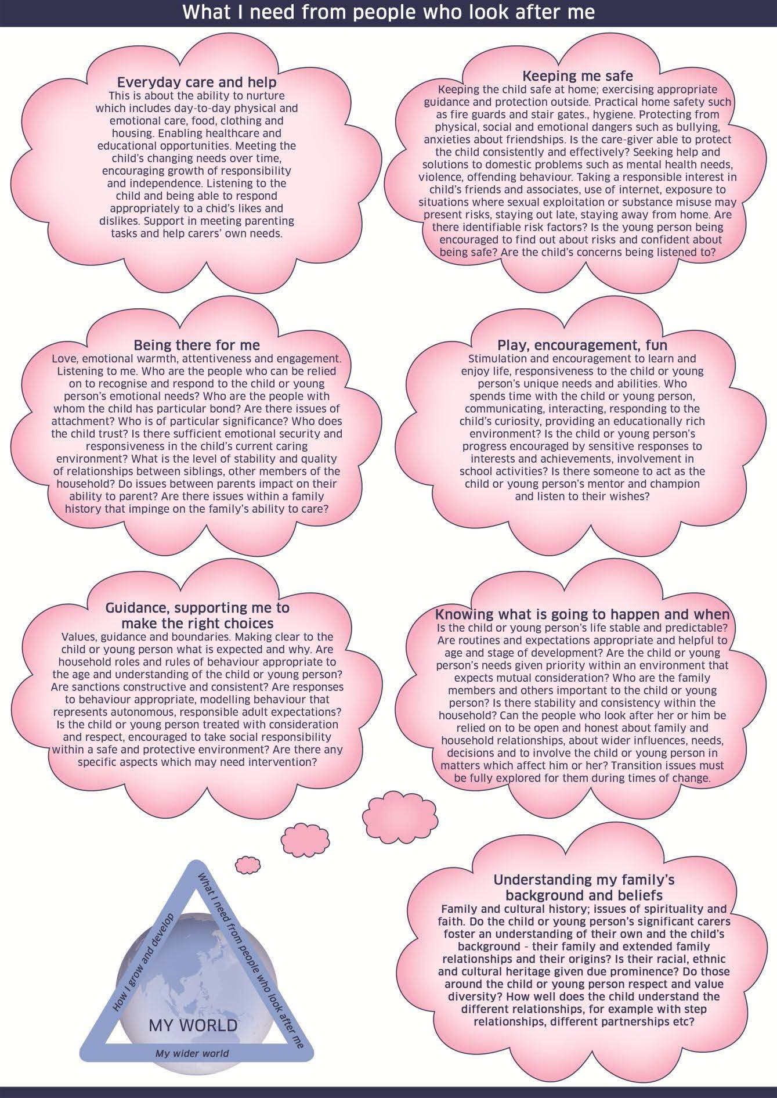

My wider world

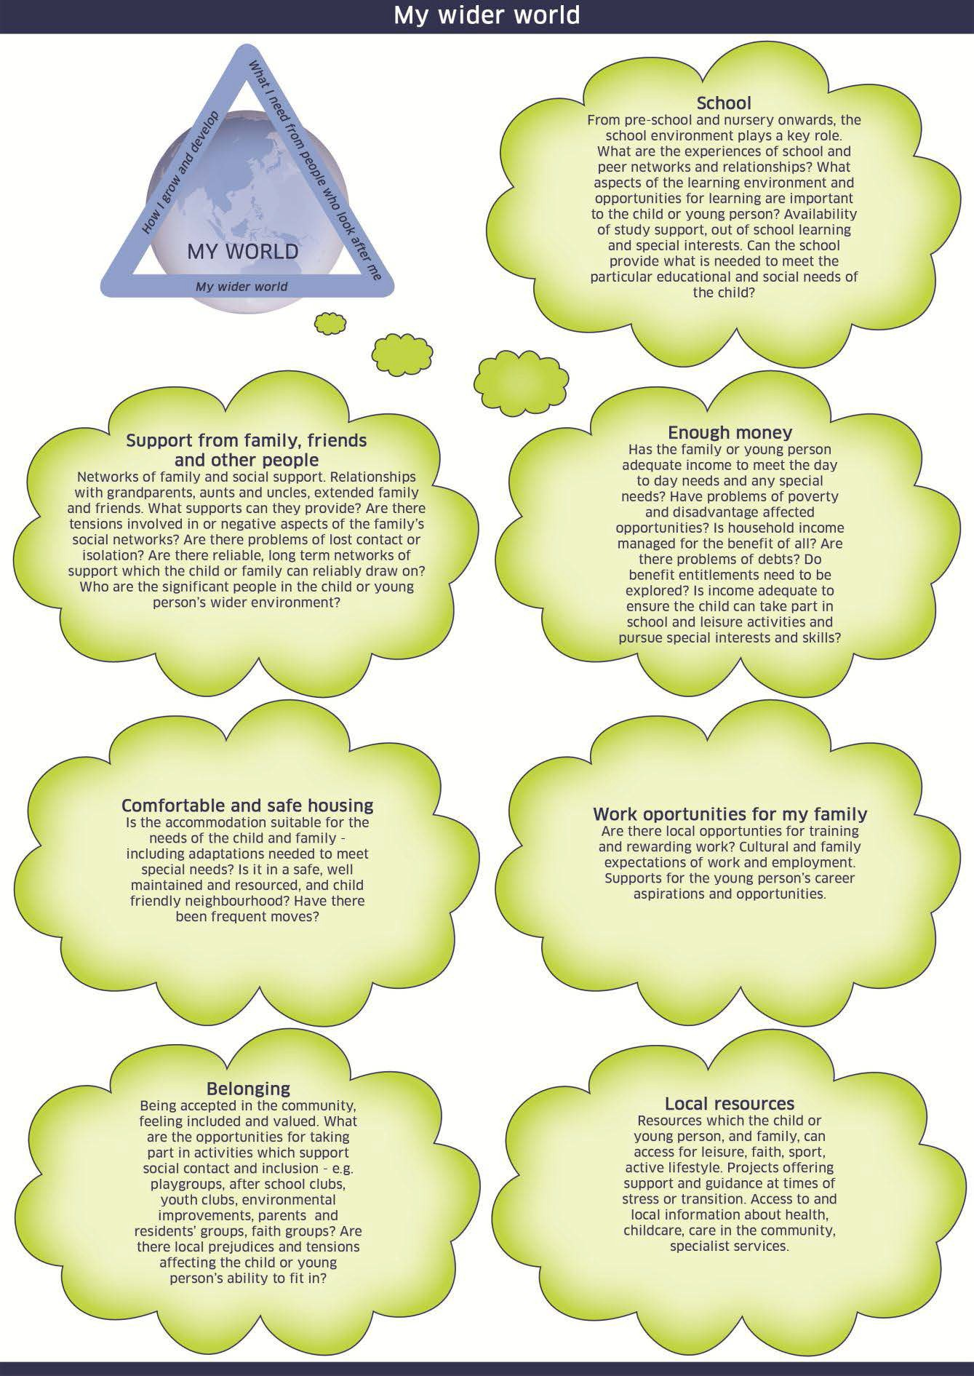

Resilience Matrix

Using the Resilience Matrix to analyse information from the My World Triangle and other sources Resilience has often been a difficult concept for practitioners to incorporate into their assessments. As such, its use within the National Practice Model has been the most difficult to incorporate.

These three building blocks of resilience offer a simple explanation of what we mean by the term:

Secure base

“I have…

  - People around me I trust and who love me no matter what
  - People who set limits for me so I know when to stop before there is danger or trouble
  - People who show me how to do things right by the way they do things
  - People who want me to learn to do things on my own
  - People who help me when I am sick, in danger, or need to learn.”

Self Esteem…

“ I am…
  - A person other people can like and love
  - A person who is happy to do nice things for others and able to show my concern
  - A person who is respectful of myself and of others
  - A person who is willing to be responsible for what I do
  - A person who is sure that in the end things will be alright.”

Self efficacy…

“I can…

  - Talk to other people about the things that frighten or bother me
  - Find ways to solve the problems I might face
  - Control myself when I feel like doing something that’s not right, or that’s dangerous
  - Figure out when it is a good time to talk to someone, or to take action.
  - Find someone to help me when I need it.”

(Groteberg 1997)

Resilience matrix: This is the model of the Resilience Matrix that appears on the GIRFEC website:

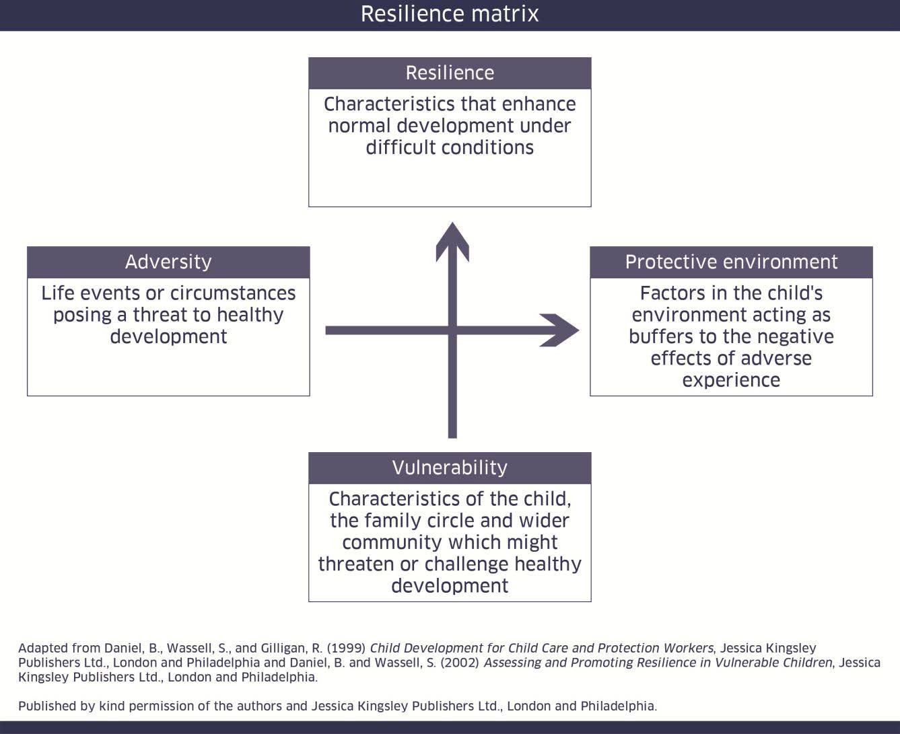

Resilience / vulnerability matrix
The slightly expanded version (below) gives some indicators of what, for example, a protective environment might look like and how to assess a child or young person’s resilience (do they, for instance, have good self-esteem? Do they show good attachment to parents or carers?)

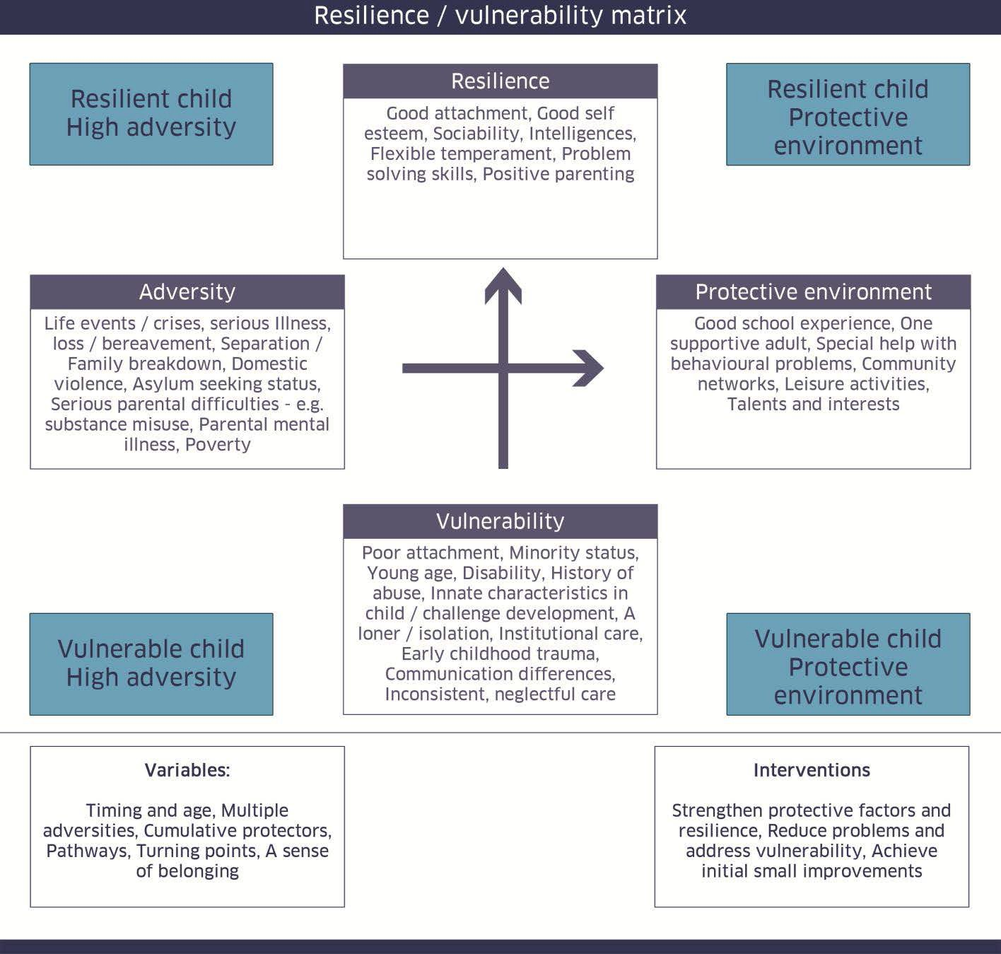

Appendices

Appendix A Chronology Appendix B My World Triangle Appendix C Wellbeing Wheel
Appendix D Child/Young Person’s Plan Appendix E Individual Monitoring Profile (IMP) Appendix F Wellbeing Cause for Concern Part 1 Appendix G Wellbeing Cause for Concern Part 2 Appendix H Child Protection form
Appendix I Permisison form to see Educational Psychologist

Appendix J Checklist

Appendix K CYP Response form Appendix L Additional information Appendix M Flow Chart

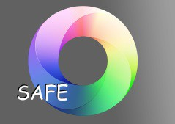
Appendix A

GIRFEC/SAFE Process

Chronology
Name of Pupil: |  |  |  | D.o.B:
Year: |  | HoM: |  | Tutor:
Date | Significant Event | Positive/Negative/Unknown impact | Source of Information | Action taken at the time or record no action | Name & signature, Role/designation

Appendix B

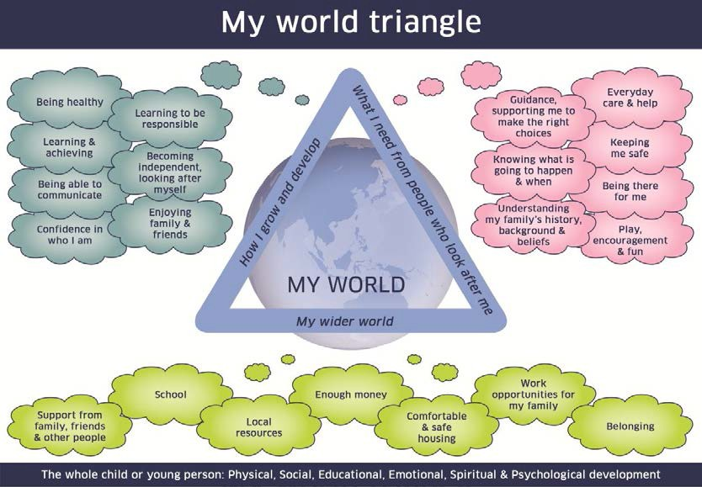

Q.V.S. GIRFEC WELLBEING WHEEL
Pupil Name Date Person Completing

Achieving means that
- You are learning new skills in school
- You are confident that you can do well
- You do the best you can
- You have hobbies and interests that help you learn new skills
- The adults in your life encourage you to do your best
- If you are struggling with your prep someone can help you with it
- You get the help you need to do well in school

Being Included means that
• You feel that you belong when you are with your friends, family and in school
• You are able to take part in activities which let you be with people that you need in your life
• You get to meet lots of different people
• You feel that other people want you around
Feeling Respected means that
- You feel that people listen to you before they make decisions which affect you
- You are involved in making decisions about your life
- If you need it, you have help to tell people about your views and decisions
Feeling Nurtured means that
You feel cared for and supported by the people who look after you.
- Where you live is clean and warm
- You have people who listen when you want to tell them about the things you need, like or dislike
- You are learning to look after yourself and make decisions that affect your life

Feeling Safe means that
- you feel protected from harm within your home and school
- The people who care for you teach you how to protect yourself from harm
- you are not scared when you go out and about
- you know when things are risky and try to stay away from danger
- The people who care for you know who you are with and where you are when you go out.

Being Healthy means that

  - You have healthy food to eat most of the time
  - You exercise a lot
  - You get the chance to spent time outside
  - The people who look after you make sure you get help when you feel ill
  - You enjoy life
  - You feel able to deal with difficult things that might happen in your life

Being Responsible means that
    - You listen to other people and try to understand their point of view
    - You know the difference between right & wrong
    - You can manage your behavior
    - You are caring and helpful
    - Adults trust you to follow their instructions
    - You are able to follow rules at school and home
    - you know what is expected of you and why
    - Adults in your life behave in a way that sets a good example

Being Active means that
- You do things for fun in your spare time.
- You have the chance to take part in leisure and sport activities
- The adults in your life help you find ways to do things that interest you in your spare time.

Being Included means that
- You feel that you belong when you are with your friends, family and in school
- You are able to take part in activities which let you be with people that you need in your life

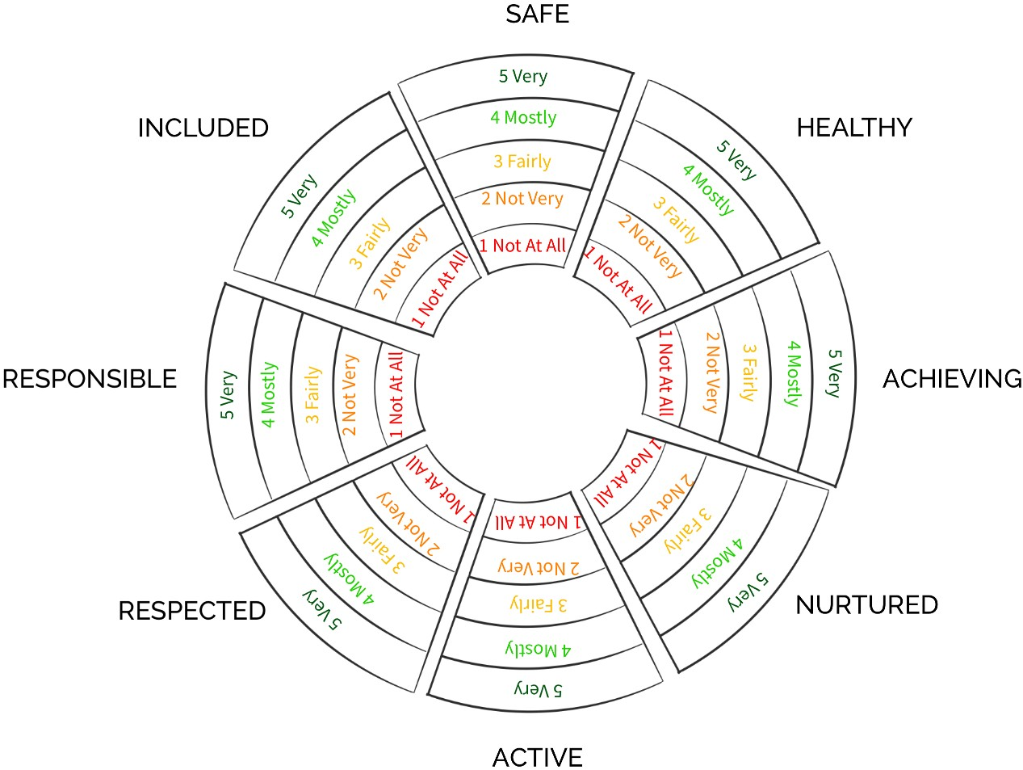
- You get to meet lots of different people
- You feel that other people want you around
V4.3 2016

Appendix D

Queen Victoria School

Getting It Right
For Every Child

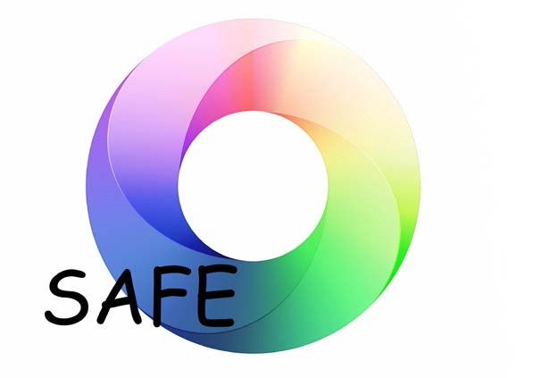

April 2016

GIRFEC/SAFE Child/Young Person’s Plan

Section 1 - Information on Child/Young Person

Section 2- Review Meeting Actions/Outcomes

Child/ Young Person: Attending meeting: Date of review: Previous concerns:

Continuing concerns/ current information:

Actions/Outcomes/ next steps planned:

Remain on Stage Move up Stage Move down Stage Remove from process Directly into Stage
S=Support A=Additional F=Formal E=Extended

Section 3 - Child/ Young Person’s Plan

Child/ Young Person: Date of this plan:
Named Person: Lead Professional:

Why does this child/young person need a plan?
Safe | Healthy | Achieving |  | Nurtured |  | Active |  | Respected & Responsible | Included
Area of Concern:
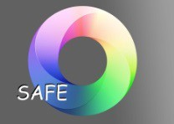  Level of SAFE | Additional |  | Formal |  | Extended
Aim/long term target/ Outcomes:

Actions/methods | By whom/when

Child/Young Person’s view of Child/Young Person’s Plan

CYP signature: Date:

Date of next review: Closure date (if or when applicable):

Lead professional signature: Date:

Section 4 - Individualised Educational Programme

Name: | Session: | Class:
Curricular area: | Staff responsible: | Date commenced:

How Delivered: | Small Group: | 1 x1: | CO OP TEACHING:

Pupil Voice:

Long term targets:

Short term targets: | Success Criteria: | Staff:
1.
2 .
3.

Resources/teaching strategies:

Evaluation Review Staff Member:

Evaluation/ Review Pupil Voice:

Section 5 Transition Planning

Notes for Transition Planning

Transition Planning must commence October S3 Year Date:

Unless family indicate intention to return to S5/6 Tick box if this is correct

Revised start of Transition Planning October S4 year Date:

Section 6 Parental/ Carer Acknowledgement and Comment

Please acknowledge that you have received this Child and Young Person’s Plan by signing and returning this section. Any comments are always welcome.

Comments:

Parent/ Carer’s name (Print): Signature:
Date:

Section 7 Update information from interim meetings

Information from update meeting ( if required):

Appendix E

Individual Monitoring Profile (IMP)
Name of CYP: |  | House:
Start Date:
Date Action Comments Staff signature

42 | P a g e

Appendix F

GIRFEC/SAFE Process

Wellbeing Cause for Concern Form – Part 1

To be completed by the person who has the concern.
- Please ensure this completed document is passed onto the HoM.
- The purpose of this form is to pass on wellbeing information about a child/young person through the routine support systems in our school.
- This form should be completed electronically or on paper

- Child/ Young Person’s Details

Name: | DOB: | Year Group:
House: | HoM:

- Person recording the concern

Name:
Role/designation:

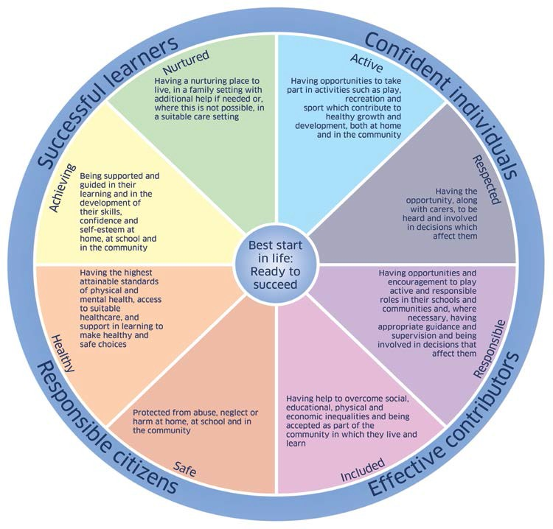
Areas of Concern. Please tick any relevant areas of the Wellbeing Wheel

Nature of Concern:
Use the headings you have ticked on the Wellbeing Wheel to record the details below:

Previous Action Taken:

PT Informed, please tick in the box if done so.

Signature: Date:

Appendix G

GIRFEC/SAFE Process Wellbeing Cause for Concern Form - Part 2
To be completed by the Named Person (HoM)
Please note: This document must be completed by the HoM. Parts 1 and 2 must be distributed to relevant staff prior to the GIRFEC meeting.

Name of CYP: | Completed by (PRINT): | Year Group:
New / Ongoing (please circle)
House: | HoM | Tutor:

  - Have there been previous wellbeing concerns? Yes/No ( please circle)

If yes please summarise with dates.

  - Has this concern been shared with the child/young person? Yes/No ( please circle)

If yes what is the child/young person saying about the concern

  - Has this concern been shared with the child/young person’s parents/carers? Yes/No ( please circle)

If yes please summarise

  - Has the concern been shared with anyone else? Yes/No ( please circle)

If yes please summarise with dates.

  - What action is being taken in relation to this concern?

Continue to monitor

Bring the Child’s/Young Person’s Needs to a GIRFEC planning meeting Initiate Child Protection procedures
Other – please give any details:

- Feedback to the referrer.
  - Name:
  - Role/designation:
  - Date:

Name of Named Person ( HoM) …………………………………………Signed…………………………………….. Date………………………….

Appendix H
CHILD PROTECTION at Queen Victoria School:

Cause for concern form

To be completed by the person who has the concern.
- If you have any doubts as to whether this CYP is a welfare or Child Protection concern, you should take advice from your Child Protection Co–ordinator.
- This form should be either handwritten or completed electronically, provided it is signed and dated in writing on the day.

Name of CYP: | Year group/age: | House:
Please state nature of concern :
Did the CYP disclose the matter to you? (If no, who did?)
Has anyone else been informed of the concern raised? (If yes, please state)

Please tick any relevant boxes from the Well Being Survey regarding your concerns.

Safe
Healthy
Achieving
Nurtured
Active
Respected
Responsible
Included

Comments:

Does the concern involve any of the following risk factors?

Concern | No | Yes
Domestic Abuse
Parental Alcohol Misuse
Parental Drug Misuse
Non-Engaging Family
Child affected by Parental Mental Health Problems
Child Placing themselves at Risk
Sexual Abuse
Child Exploitation
Physical Abuse
Emotional Abuse
Physical Neglect
Other (please specify)
Unsure

Name of Staff : | Signed:
Date: | Time:

Please ensure you have signed and passed this information to the Child Protection Co-ordinator as soon as possible and on the same working day.

CHILD PROTECTION at Queen Victoria School: Cause for concern form
To be completed by the Child Protection Co-ordinator.
Q.1. Have there been previous wellbeing concerns?
Yes
No

Yes (If yes, Please summarise)

Q.2 Did the current concern involve any of the risk factors?
Yes
No

Q3. Is the CYP currently on the Child Protection register?
Yes
No

(If yes, the concern should be referred on the day to the allocated social worker or their senior).

Decision: | Please tick | Action: | Please tick | When?
Initiate Child Protection procedures |  | SA to interview CYP(s) with witness present:
 |  | Inform HEAD /SDHT /DHT (PS)
 |  | Referral to Social Work
 |  | Referral to Police
Refer as Wellbeing matter |  | Inform HoM
 |  | Inform Parents
 |  | Inform Medical Centre
 |  | Separate and secure CYP in safe place
 |  | Review meeting organised with relevant staff

If you have any doubt as to whether you have a wellbeing or Child Protection concern, you should take advice from the social services.

Name of CP Co-ordinator: | Signed:
Date: | Time:

Appendix I
QUEEN VICTORIA SCHOOL

PARENT/CARER FORM,

RETURN or EMAIL to HoM

Name Pupil: ……………………………………………………………………………. Date of Birth: …………………
House: ……………………………………………………………………………. Year: ………………………………
Date completed: ………………………………………………………………………………….

Following discussion with …………………………………………………. from Queen Victoria School, I agree
to my son / daughter seeing ……………………………………………………………………

I understand that I shall be consulted and included through the planning / review process,
known as GIRFEC (Getting it Right for every Child).

Name in Caps: …………………………………………………………………………………………
Signed: …………………………………………………………………………………………

Parent / carer’s preferred method for contact, should this be required:
Phone: ………………………………………………………………………………..
Email: ………………………………………………………………………………..

Reason for request for involvement

What are you hoping to achieve from request

Relevant background information

Parent/Carer/Young Person comments

Parental /Young Person Consent:

I consent to the involvement of Targeted Services (Senior Educational Psychologist/Senior Education Social Worker/Counsellor) with my child and/or family. I consent to Pupil and Family Services collecting, storing and using the information on this form in line with the DCYP Policy on Data Protection.

Parental signature/Young Person’s signature: |  | Date:

Appendix J GIRFEC
Stage checklist

Checklist for SAFE process Check  AFE process Check | Responsibility
1 Chronology initiated, up to date and accurate | HoM
2 Initiate IGF to ALL staff involved in life of CYP  ALL staff involved in life of CYP | HoM
3 Cause for Concern completed  cern completed | HoM/ Staff
4 Collate all required information from WCBS | HoM
5 Complete National Practice Model from WCBS  onal Practice Model with CYP | HoM
Complete SHANARRI assessment with other staff if required (use My 6a World Triangle and Resilience matrix if required) | HoM
6b Correspondence with parents reference: moving up or down Register | via PLAN
7 Correspondence with parents reference: removal from Register | HoM
Compile all information for review meeting with DHT PS and PS  8 Dept | HoM
9 DHT PS Action Points checked  n Points checked | DHT(PS)
10 CYP Plan created at review meeting  ted at review meeting | GIRFEC  Team
11 Action points created | DHT(PS)
12 Review date set | GIRFEC  Team
13 Contact outside agencies, if required | DHT PS
14 Contact parents  s | As agreed
15 Contact other staff if required | As Agreed
16 Monitor and record  cord | HoM
Discuss Plan with CYP who will sign and comment and complete  17 CYP Response to Plan | HoM
18 Pass Plan to DHT PS to send to parent  HT PS to send to parent | HoM

Appendix K GIRFEC
CYP Response to Plan

HoM to consult with pupil about the plan to assess effectiveness of Plan, prior to review meeting:

Name of CYP: |  |  | Date of conversation:
Name of HoM:
Pupil comments:

What do you feel is working well? What do you feel isn’t working so well?
Is there anything else that is concerning you at the moment? Other comments:
I am happy with the comments being made  CYP signature: | Date: | HoM signature: | Date:

52 | P a g e

Appendix L

Additional Information

All paperwork templates and information are on the shared drive – GIRFEC Pupil File Master Copy.

Five GIRFEC Questions should be used as part of the PRACTICE MODEL to be integrated into the QV approach:

- What is getting in the way of this child or young person’s wellbeing?

- Do I have all the information I need to help this child or young person?

- What can I do now to help this child or young person?

- What can my agency do to help this child or young person?

- What additional help, if any, may be needed from others?

A STAGE PLANS will be reviewed termly but there will be an update on progress at appropriate intervals.

F and E STAGE PLANS will be formally reviewed, termly.

Notification of Closure of Plan will be indicated on PLAN. Informal contact to parent regarding movement up or down the Register will be carried out by HoM.
The information stored by HoMs on each child in an individual folder is as follows:

Contact information Chronology
Cause for concern forms Plan
IGF IMP

QA takes place termly at HoMs Dev and Pupil Support will attend for GIRFEC consistency.

Agenda will be agreed at the end of each GIRFEC Meeting and will include AOB. Pupil Support will send out Agenda.

- | P a g e

Appendix M

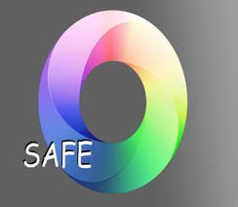
Queen Victoria School GIRFEC/SAFE Process

Progress now satisfactory remove from register.
Ongoing House/Department concern(s) identified by teacher, parent or child or HoM or through Educational Psychologist (EP) drop in.
Behaviour Management: in class, teacher uses classroom Discipline Record for initial concerns actioned. If continuing then PT becomes involved. Dept. Discipline record used. In the House, staff log incidents.
There may be circumstances where immediate action is required due to the nature of the concern. A Young Person may be moved to Additional, Formal or Extended Stage.

Behaviour Management: if required due to behaviour a CYP may be suspended or excluded

HoM notified.

Support Stage
GIRFEC Forum: Young Person highlighted and placed on Support Stage.

Support Stage Register reviewed.

On-going concerns. HoM to initiate gathering of information and SHANARRI. PS Department may carry out assessments. Parent informed by HoM.

Additional Stage.
Behaviour Management: at this stage the HoM may decide to put the YP on a House Support card or Tutor card. This card includes Tutor/House monitoring. Card is issued by tutor (3 weeks with extension option); YP presents the card to duty tutor at agreed time; YP presents to HoM at end of week.
Produce Additional Stage plan during next review meeting. Move to Additional Stage and amend register as pending until Plan is produced. HoM to gather information for next meeting. Additional Stage review date set.

Additional Stage Review meeting held.

Formal Stage.

Further concerns. Move to Formal stage and amend register. PS Department and DHT (PS)possible gathering of information. Formal Stage plan produced.
Behaviour Management: this Plan may have a tutor card or an SLT card (orange).
HoM to gather information for next meeting. Formal Stage review date set.

Formal Stage Review meeting held.

Extended Stage.

Further concerns. Move to Extended Stage and amend register. PS Department and DHT (PS) possible gathering of information . Extended Stage plan produced during meeting. HoM to gather information for next meeting. Extended Stage review date set.

Extended Stage Review meeting held.

Involvement of staff at appropriate GIRFEC/SAFE meetings: Support Stage- can include HoM, PS Department, DHT( PS), EP for consultation only;
Additional Stage-may include HoM, parents, Young Person, PS Department, DHT (PS), EP, Medical Centre staff, outside agency (short term);
Formal Stage- may include HoM, parents, Young Person, PS Department, DHT (PS), EP, Medical Centre staff, outside agency (long term);
Extended Stage- may include HoM, PS Department, DHT (PS), EP, Medical Centre staff, outside agency (long term).
Queen Victoria School’s Behaviour Management Policy is also integrated into the above SAFE/GIRFEC Process

Acknowledgements

The school would like to take the opportunity to acknowledge and thank the contribution and support of the GIRFEC Forum in designing the S.A.F.E intervention process.

Graeme Beattie (PT Pupil Support) Sally Johns (Pupil Support)
Jenni Barr (School Ed Psychologist) Margaret Skeith (Medical Centre) Paul Bush (HoM)
Rebecca Appleyard (HoM) Niall Lear (HoM)
Mike Eastham (HoM) Carole Phipps (DHT PS) Steve Adams (DHT P&G)

The school would also like to thank David Gilhooly (PT Art) for his time and efforts spent designing the S.A.F.E logo and to Mary and Jackie (Barnardo’s) for volunteering their time to provide help with the initial GIRFEC training.

- | P a g e

